# Module-8

(Bootstrap Basic & Advance)

1]What are the advantages of Bootstrap?

A] ~Bootstrap is for faster & easier web-development

~Bootstrap includes HTML & CSS based design templates for easy use

~Bootstrap also helps us to easily create responsive designs

*Advantages:

* Responsive design:

Bootstrap is designed to be responsive, meaning that it will automatically adjust its layout to fit any

screen size.

* Pre-built components:

Bootstrap includes pre-built components, such as buttons, forms, and navigation bars.

* Customization:

This can be done by changing the color, fonts, and other aspects of the framework

* Community:

Bootstrap has a large and active community of developers. This can be a valuable resource for developers

who need help or advice.

2]What is a bootstrap container, and how does it work?

A] A Bootstrap container is a responsive layout element that is used to contain the content within it.

There are two types of Bootstrap containers:

* container class provides a responsive fixed-width container. This means that the container will automatically adjust its

width to fit within the viewport of the device it is being viewed on.

* container-fluid class provides a full-width container, spanning the entire width of the viewport
* Ex:

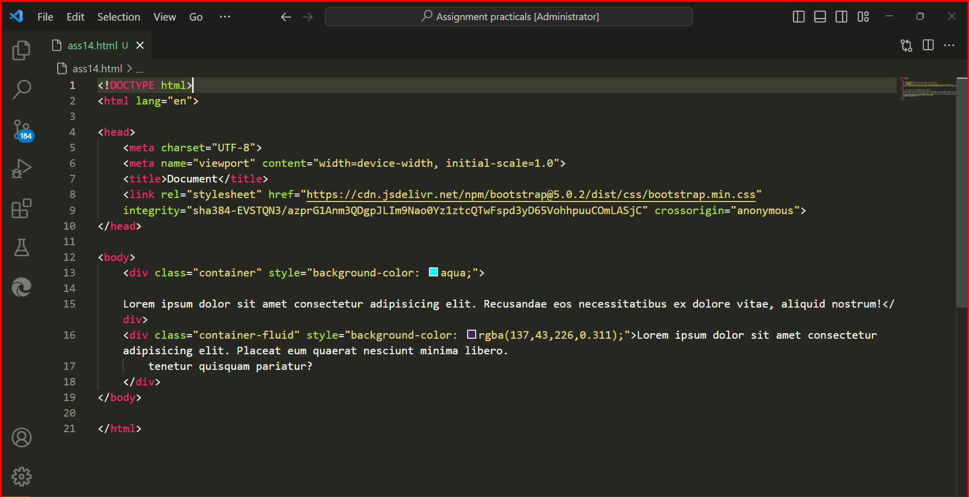

3] What are the default Bootstrap text settings?

A] The default Bootstrap text settings are as follows:

● Font-size: 16px

● Line-height: 1.5

● Font-family: "Helvetica Neue", Helvetica, Arial, sans-serif

● Font-weight: normal

● Color: black

In addition to these default settings, there are a number of Bootstrap utility classes that can be used to style text in

different ways.

4] What do you know about the Bootstrap Grid System?

A] The Bootstrap grid system used to create responsive and consistent layouts. It is based on flexbox, which is a modern CSS layout system that is designed to be responsive.

* The Bootstrap grid system divides the page into a series of columns, and each column can be assigned a width.
* The Bootstrap grid system is based on flexbox.
* The Bootstrap grid system is fully responsive.
* The Bootstrap grid system is very flexible.

The columns can then be arranged in rows to create different layouts.

* The Bootstrap grid system is made up of the following components:

● Containers: Containers are used to wrap the content that you want to place in the grid.

● Rows: Rows are used to arrange the columns in the grid.

● Columns: Columns are used to define the width of the content.

● Grid gutters: Grid gutters are the spaces between the columns. They help to create a more visually appealing layout

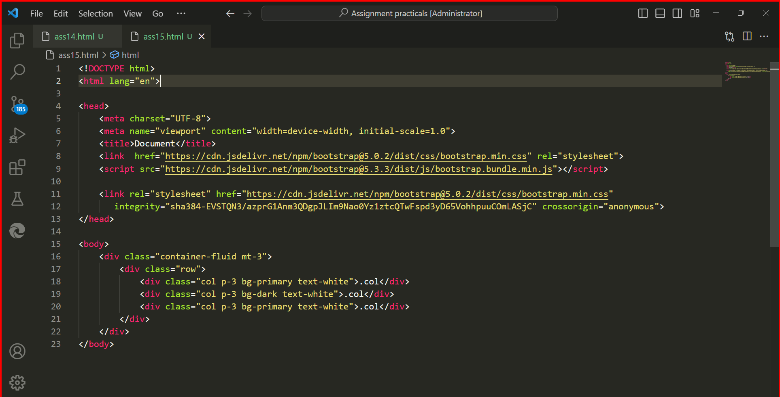

The Bootstrap grid system has six default breakpoints, The breakpoints are as follows:

● Extra small (xs): Phones

● Small (sm): Tablets

● Medium (md): Desktops

● Large (lg): Laptops

● Extra-large (xl): Desktops and large

● Extra extra large (xxl): Large displays

5]What is difference between Bootstrap 4 and Bootstrap 5

A]

|  |  |  |
| --- | --- | --- |
| Feature | Bootstrap 4 | Bootstrap 5 |
| Support for older browser | Supports internet explorer 10 and 11 | Does not support internet explorer 10 and 11 |
| Grid System | Based on flexbox, has five default breakpoints | Based on flexbox, has six default breakpoints |
| Components | Includes a number of components, such as cards, forms, and tables | Includes a number of new components, such as accordion, carousel, and offcanvas |
| Theming system | Uses Sass variables to customize the look and feel | Uses Sass variables and a new theming system to customize the look and feel |
| Accessibility | Has some accessibility features | Has improved accessibility features |

6] What is a Button Group, and what is the class for a basic Button Group?

A] A button group is a Bootstrap component that allows you to group a series of buttons together. This can be useful for creating a toolbar or for grouping related actions.

* The class for a basic button group

is. btn-group.

* This class will automatically apply some basic styling to the buttons, such as rounding the corners and adding a small margin between the buttons.
* This will create a button group with two buttons, one with the primary color and one with the secondary color.
* You can also use the. btn-group class to create a vertical button group.
* To do this, add the. btn-group-vertical class to the <div> element.

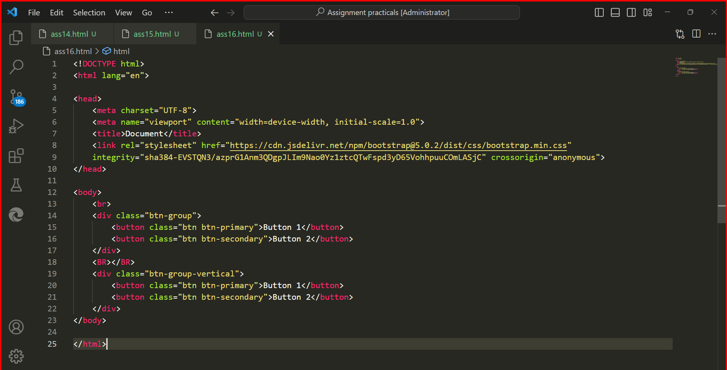

7] How can you use Bootstrap to make thumbnails?

A] .img-thumbnail class to create a thumbnail image. This class is a shorthand for the. thumbnail class, and it is more commonly used.

The. rounded class will add a rounded border to the image.

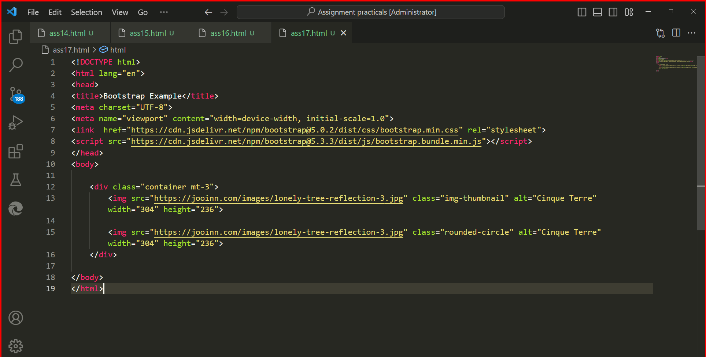

8] In Bootstrap 4, what is flexbox?

A]

* Flexbox is a CSS layout method that is used to arrange items in rows or columns. It is a more flexible and efficient way to layout content than traditional CSS methods, such as floats and positioning.
* Bootstrap 4 uses flexbox to power its grid system and other layout features.
* This makes it easier to create responsive and
* dynamic layouts that work well on all devices.

9] How can one create an alert in Bootstrap?

A] To create an alert in Bootstrap, you can use the. alert class. This class will automatically apply some basic styling to the alert, such as a border, a background color, and a padding.

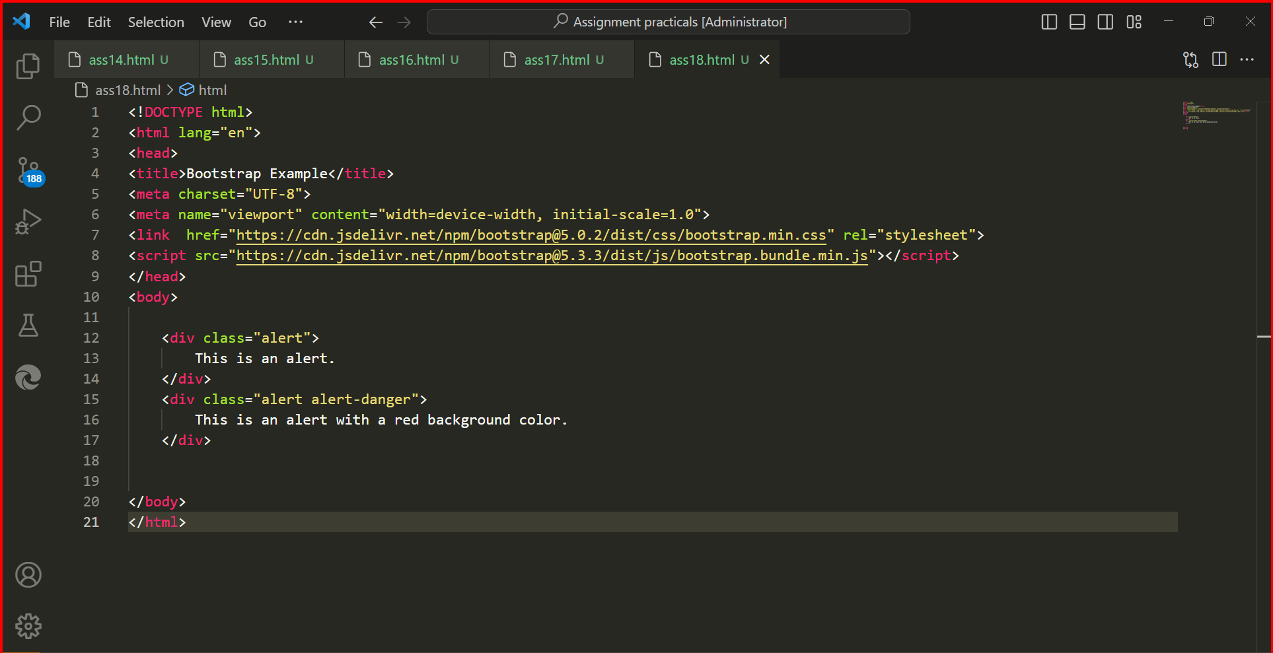

10] What is a bootstrap card and how would you create one?

A] A card is a flexible and extensible content container. It includes options for headers and footers, a wide variety of content, contextual

background color, and powerful display options

